Go to <https://developers.facebook.com/apps/>

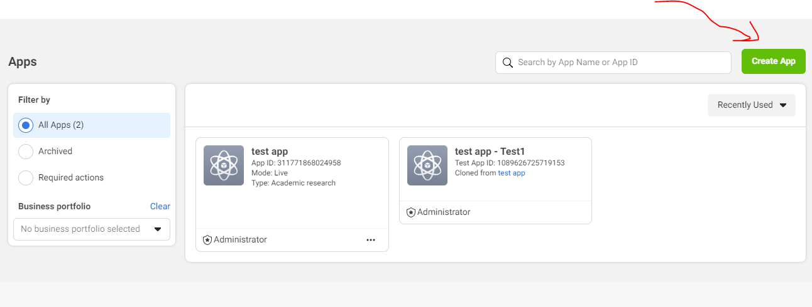

Hit “Create App” 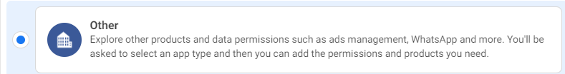

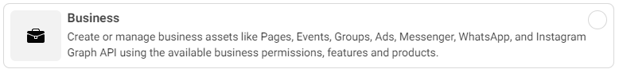

Select this “Other” then “Business”

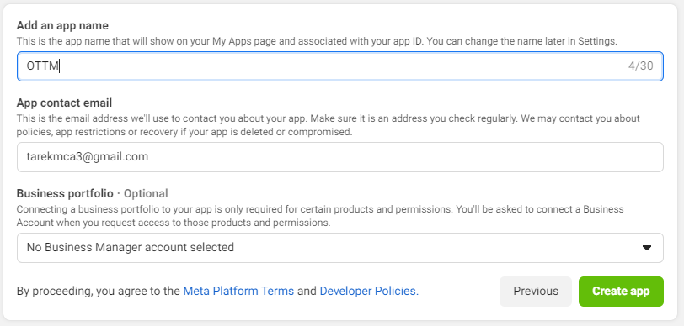

Pick a name then “Create app”

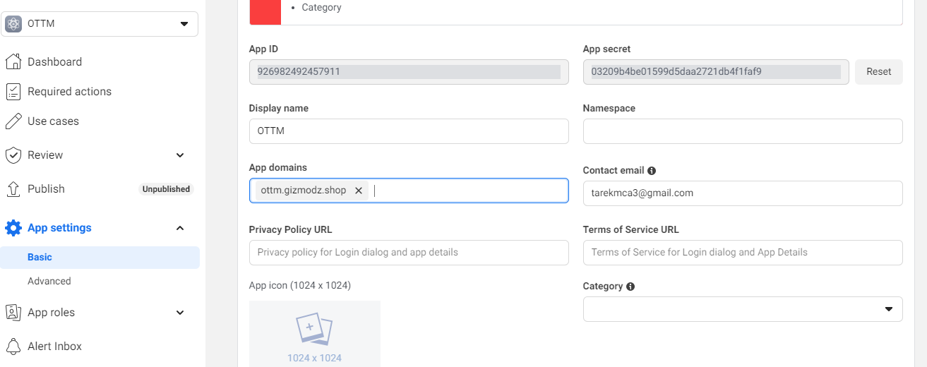 Go to “App settings” then “Basic” then fill App domains by “ottm.gizmodz.shop”

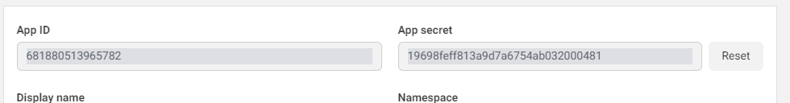

Get the App ID & App secret

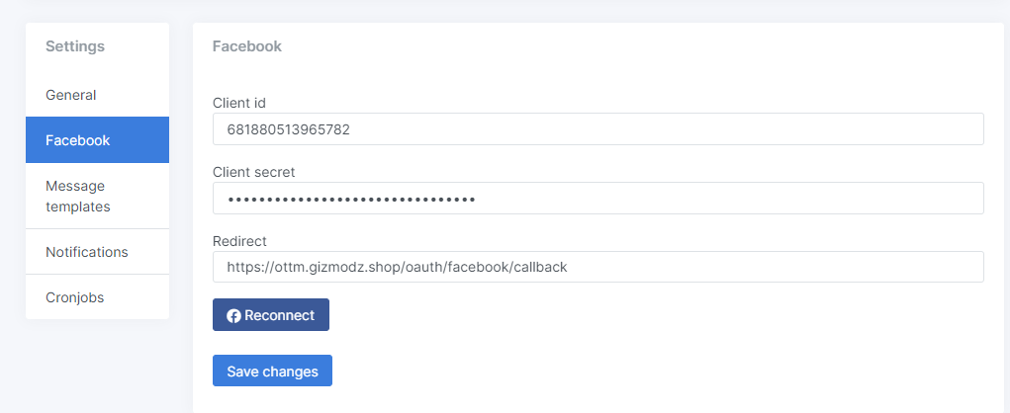

Put them In settings/Facebook on “<https://ottm.gizmodz.shop/settings>” page & click save

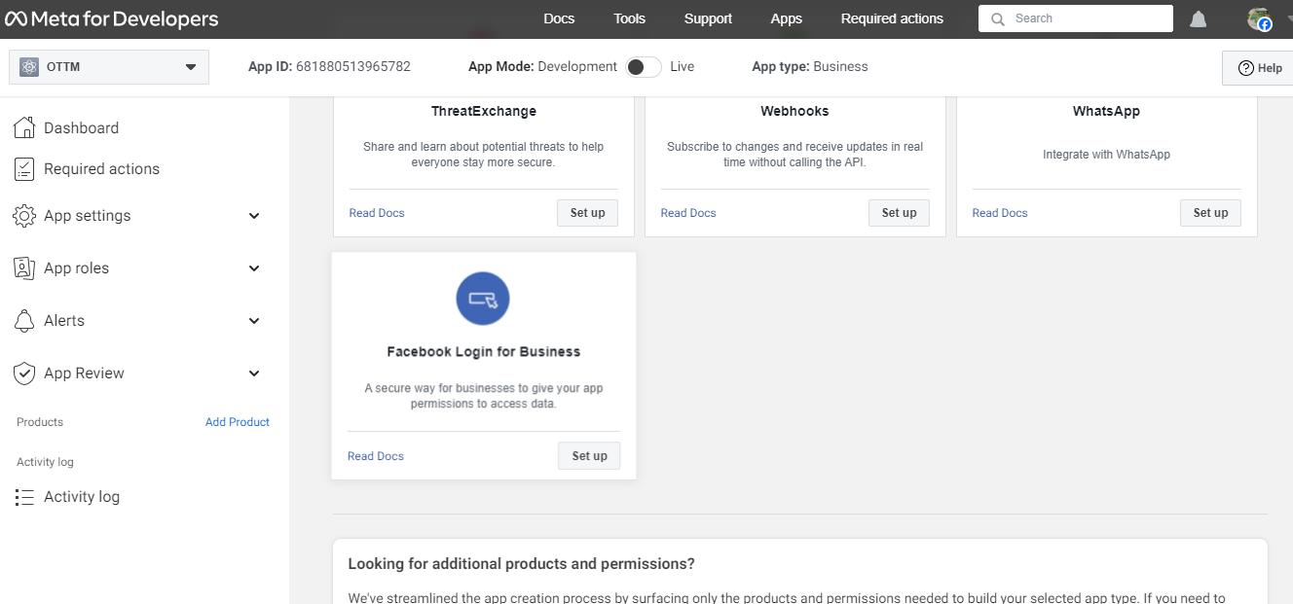

Go to “Dashboard” then select Facebook Login (click Set up)

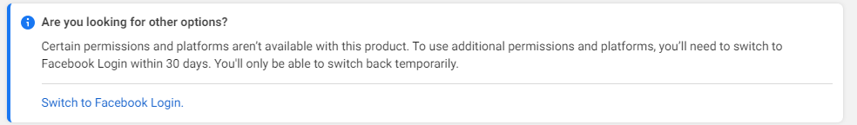

Switch to Facebook Login

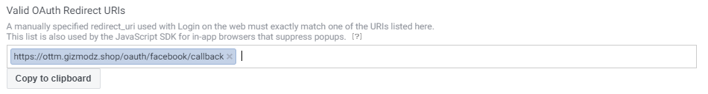

Go down then put“<https://ottm.gizmodz.shop/oauth/facebook/callback>”as a valid OAuth redirect url



Go back to settings/Facebook on “<https://ottm.gizmodz.shop/settings>” page & hit Reconnect

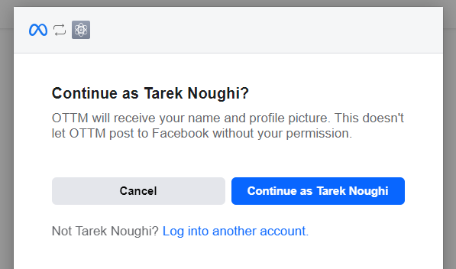

A page like this should appear to you Click continue as “Your facebook name”

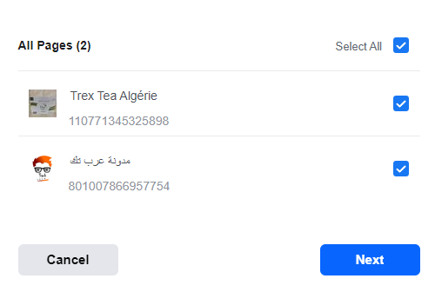

Select all of your pages then click Next Then Done



The system is active now

**How to use OTTM**

* Add your delivery desks from <https://ottm.gizmodz.shop/desks>
* Then your assign to each wilaya a desk from <https://ottm.gizmodz.shop/wilayas>
* You can select the delivery prices manually or click Auto update prices (after assigning desks)
* Add the product you sell on <https://ottm.gizmodz.shop/products>
* You can check conversations on <https://ottm.gizmodz.shop/conversations>
* Create foreach of your workers an account on <https://ottm.gizmodz.shop/users>
* you can also ask them to create an account from <https://ottm.gizmodz.shop/resiter> in this case you have to assign a role and permissions in order for them to have access to the platform.
* On settings page <https://ottm.gizmodz.shop/settings> you can edit the general settings of the platform including message that the platform should send to customers.
* In order to the platform to start working automatically you should activate all the cronjobs on settings page.

**Enjoy**